Agile Dev Assist — One Pager
Oct 16, 2026 · @Pratik

What it is
Agile Dev Assist turns a user story into reviewed, repository-ready code in under 10 minutes. A developer drops in the story, the team's skills, glossary, standards, Greenplum tables and the git repository; a team of seven AI agents analyses them, plans the change, writes every file (including the companion scripts, DAG registrations and config entries that are usually forgotten), validates and reviews the result, and pushes a branch under the developer's own name. The same application runs as a web app with SSO or from a Jupyter notebook, for any team and any language (SQL, Python, Airflow, R, notebooks).

The idea in plain words: a new developer joins the team
The LLM is a brilliant senior engineer who joined the team this morning. It knows SQL, Python and Airflow better than anyone, but it has never seen our applications: it does not know what acc_mhh_n means, where profile scripts live, that every new table needs a history script and a TABLE_CONFIG entry, or which DAG registers which folder. Left alone, such a person writes clean code that is wrong for us.
Agile Dev Assist is the onboarding that a good team gives that newcomer, done automatically on every story:
What a team does for a new developer | What Agile Dev Assist does for the LLM
Hands over the story and explains what is really asked | Story agent reads the ticket, extracts requirements, rules, tables and the SQL in it
Points to the wiki, glossary and coding standards | Knowledge agent turns skills, glossary and standards files into definitions, conventions and checkable rules
Gives database access and explains the tables | Data agent describes the Greenplum tables and queries (columns, types, samples)
Walks through the repository: "this is how we do it here" | Repo agent indexes the code, finds the files to imitate, the files to modify, the registration points and the companion files
Agrees a design before coding | Planner agent writes the approach, the modules and intermediate tables, every file and its purpose
Lets them code, one file at a time | Coder agent writes each file in parallel, following the patterns found
Runs the linters and does the code review | Validator (syntax, Airflow, SQL parse, standards rules) and Reviewer agent (requirements, story code, registration, impact, standards) with a fix loop
Each agent is the same expert given one job, the right documents and the right tools; what they learn is written down (JSON) and handed to the next one, so nothing lives only in someone's head.

How the agents work
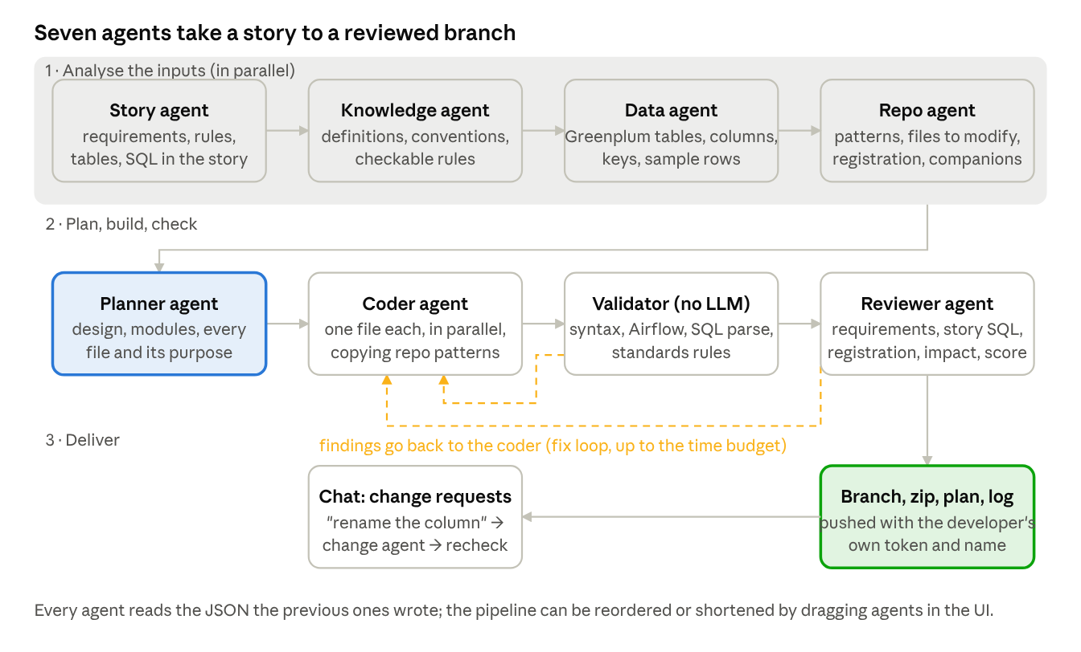
agent pipeline · 7 agents, 1 validator, 1 fix loop
Four analysis agents run in parallel on the inputs; the planner merges their JSON into a design; the coder writes every planned file in parallel; the validator and the reviewer send findings back to the coder until the code is clean or the time budget (10 min) is spent.
What makes an agent more than a prompt:
- Tools, not guesses. Each agent can call search_repo, read_file, registration_points, companion_files, references, describe_table, define_term. The repo agent reads the real DAG before saying where a task is registered.
- A contract. Every agent must return a JSON schema (e.g. the planner: approach, design, files, registration_changes, impact, test_plan). Free text is rejected.
- Grounding checks. Deterministic code checks the answer against the facts and sends it back with the reason: a planned "modify" of a file that does not exist, a story SQL block nobody used, a registration point or companion file (history script, TABLE_CONFIG, DAG) neither planned nor explicitly declined, a file that does not parse.
- Memory on paper. Results are cached per input, so re-running a story after a small change only recomputes what changed; every call is traced with its tokens per agent.

Inputs and outputs
Everything the developer drags into the chat is standardised to JSON, so any team can use its own documents.
Input | Accepted as | Becomes
User story | GitLab / GitHub issue, file, upload or pasted text | requirements, business rules, acceptance criteria, tables, SQL blocks
Skills, glossary / data dictionary, standards & conventions | md, yml, yaml, txt, csv, xls, xlsx, doc, docx, html | definitions, conventions, regex rules the validator enforces
Greenplum tables and queries | schema.table list or SQL (read-only) | columns, types, keys, sample rows, query result shape
Git repository | GitLab / GitHub URL + branch (shallow, sparse download) or local folder | searchable index: symbols, patterns, registration points, companion files

Output | Where
Branch storyid-repo-feature pushed from the base branch, commits under the developer's own name | Outputs tab → Push (personal token required)
Zip of all generated files, plan, review, log, token stats | Outputs tab downloads
Files editable in the UI before pushing; chat change requests re-run the checks | Files tab, chat
Optional docx / pptx summary of the change | Outputs tab

Guardrails
- Code usable as is. Story SQL is treated as the specification; logic lives in small modules / intermediate tables distributed by the join key; profile and history scripts stay simple; every new script is registered and every companion file is changed or explicitly declined.
- Review before you see it. Deterministic validator (python ast / pyflakes, Airflow checks, SQL parse with Jinja parameters, team regex rules) plus an independent reviewer agent with a 0-100 score and verdict; findings loop back to the coder.
- Secrets never stored. Azure OpenAI key from an environment variable or a hidden notebook prompt; git read token asked once at launch; a push always needs the developer's personal token typed in the form; nothing is written to config, cache, chat history or logs.
- Per-user, per-session. SSO (header or OIDC) in the web app, dev login in the notebook; chats, inputs, files and outputs are stored per user; delete your own chats.
- Cost visible. Token counts per agent and per run in the log and the Tokens tab.

How it decides which code to create or change
Three sources of evidence, each of which must become a file (create / modify) or be declined with a reason, or the plan is sent back:
Evidence | Found by | Becomes
Tables and SQL in the story | story agent | the new intermediate module that holds the logic; the table script gets only a LEFT JOIN + columns
Who registers the scripts of that folder (DAG task list, task-name file, config) | registration_points on the repository | a modify of the DAG / config (safety net adds it if the planner forgets)
What changes together with the table: same-table script in a sibling folder (history / archive), configs with an entry for it, readers | companion_files, references | history script create / modify, TABLE_CONFIG entry, impact list
Conventions in skills / standards ("a new profile table needs its history script"; "logic lives in intermediate tables") | knowledge agent | rules the planner must apply and the validator can check

Confidence score
One number per run, shown in the header and the Review tab with its formula: 40% validator quality + 35% reviewer score + 25% coder confidence, capped by what is still open (review skipped → max 70, open critical finding → max 50, open high → max 75, a file with coder confidence below 60 → max 80, −2 per open plan question). High ≥ 85 (read plan, skim diff, push), Medium 70-84 (fix what the Review tab lists), Low < 70 (the tool is pointing at a problem). 75% of the score comes from signals independent of the model that wrote the code.

Demo in five steps
- Open the UI from the notebook button (or the web app) and sign in; a new chat opens.
- Drag in the story from GitLab issue 2547, the skills, glossary and standards files, the Greenplum tables, the ikg-dags repository; each becomes a card in the chat.
- Drag the agents to build the pipeline (default order) and press Run; watch the stage chips turn green.
- Read the Plan tab (design, files, registration, impact, test plan), the Files tab (edit inline), the Review tab (score, findings).
- Push the branch with your personal token, or download the zip and the log.
A change that takes a developer one to two days of reading the repository, writing, registering and self-reviewing comes back in about 5-10 minutes as a reviewed branch; the developer stays the author and the final reviewer.

